Lakemoor Community Club Board of Directors Minutes –

Meeting type: Regular
Date: September 9, 2019
Place: Garfield Middle School Library
Start time: 6:08 pm

Board members in attendance: President Wendy Harris, Treasurer Rob Panowicz, Secretary Dirk Havlak, Mike Gowrylow, Susan Dumph, Randy Lubert; John Ulmer absent

Community members in attendance: Michele Rothman – Ken Lake Clerk, Gary Westling, Rita Westling, Linda Panowicz, Pat Ames, Al Hatten, Ralph Oliver - Security

Minutes: August 5, 2019 minutes reviewed. WH suggested a clarification. After that edit, Rob moved, Mike seconded, and minutes were unanimously approved

Community Comments: Gary Westling (2225 Lakemoor Dr) spoke about 2 dead trees, one on edge of his property, one nearby in the Urban Forest. He is having several consultants come by to discuss removing his tree, and how this might impact the UF. Discussion ensued about whether to cut both trees and let them fall into UF since removal is costly and probably more disruptive to UF than letting trees stay down and letting nature take its course. Board member Mike, also on ACC, agreed to meet with Gary and the first consultant tomorrow. The board also wants to get UF committee opinion on this.
Gary has not submitted anything about this to ACC, as he wanted board’s opinion first since UF potentially involved.

Reports:
Security – Ralph described 2 incidents in the community over the last month. On 8/26/19 at 6pm he was called to Christopher Park because 8 kids, believed to be from Capital High and non-residents, were rocking the floating dock. Ralph confronted them and took pictures which he will sent to Rob P who offered to show them to CHS personnel for possible identification. Board members asked Ralph to call OPD next time as the non-resident kids are trespassing, and warnings alone have not been effective deterrence. The board authorized and had installed additional signage this summer, suggested by OPD, to make OPD action regarding trespassers more enforceable. Rob has talked with CHS principal earlier this summer regarding trespassing incidents by CHS students which could generate OPD action in the future, and this was conveyed to coaching staff.
On 8/27/19 several mailboxes were badly damaged by a vehicle. Susan D. knows the teenager involved and repairs are being arranged. Ralph only heard about this later by email, wondered why he was not notified earlier.
Randy L commented that unsecured boats at Christopher Park have been used by non-residents for fishing. Boat owners need to be advised to lock up their boats, this can be added to newsletter and email. The proposed new lake park security system should help with several of these issues.
Dirk asked whether Ralph noted less inappropriate activity at the lake parks this summer over previous. Ralph thought activity was probably less.

Treasurer – Rob P reported he moved $20,000 from operational savings into operational checking. See attached Treasurer’s report. Other notes:
1) As reflected in the summary financial statements from Vantage, we are tracking closely with our budget.
2) In September our outside consultants will review and update our current (2017) reserve study.
3) A complete reserve study will take place in 2020, and will include a study of our lake in light of the continued rise of silt levels. (see Aspect Consulting’s report posted on our web page).
This may result in an increase in our reserve fund requirements to provide for remediation.
4) LCC is in the process of being audited by the Washington State Dept of Labor & Industries. The results of the audit are not known. It revolves around the classification of our independent contractors’ coverage for industrial insurance purposes. Our potential liability, should the auditor determine that our historical treatment of our service providers as independent contractors does not conform with L&I regulations, is estimated to be less than $3000.
5) The board is in the process of reviewing the contracts with all of our service providers. We have completed the review of the Parks Manager, Ken Lake Security and our Corporate Secretary and renewed those contracts.
We will next be reviewing our management company contract and reserve study contract. We expect to send out RFP’s in the next few months. Once a comparative analysis of the proposals is complete we will invite the top 2 to 3 companies to make presentations to the board before reaching a decision.

Rob noted that attorney Ed Younglove has provided consultation, so far at no charge to LCC.
Wendy stated that the L&I audit was likely the result of a community member complaint.

Covenants – Randy L gave report in John U’s absence. Proposed Rules & Regulations to clarify our 2008 Covenants has been submitted to attorney Stephen Smith for review. The committee is also working with the attorney on the fine structure for covenant violations. The attorney’s comments will be reviewed by Covenants committee prior to forwarding to board. After board review, the R&R package will be distributed to community membership for 60 day comment period.

Architectural – Mike G gave report in Bruce Treichler’s absence. The ACC reviewed 7 notifications regarding issues such as tree removals, fence/walls/bulkhead construction, and a treehouse. All were deemed acceptable. Bruce has details.

Common Areas – Brian Frankowski could not attend.
Brian has provided the board with a detailed “Gate Security Upgrade – Vendor Analysis” report. See New Business below. No other report received.

Events –Michelle Rothman is organizing a Fall Festival for Sunday, Oct 20 from 3-5 pm, similar to last year, to occur in Christopher Park. She started a Signup Genius for that event.
Dirk and Dixie Havlak will host a “Ken Lake Holiday Hay Ride with Crafts, Carols, Cocoa, & Cookies” at their house on Sunday, Dec 15, from 5-8 pm.

Gardens – Christina Morse absent but provided written report that Fall Garden planting has occurred. Children have been leaving the hose and nozzle in the sod – out of respect for the volunteer mower, Kathy Hibbert, please return the garden tools to inside the middle of the garden beds. Contact Christina regarding input and participation, plots are available for fall gardening.

Lake/Stormwater - Al Hatten presented his report verbally and in writing.
Lake – See Al’s attached report. Lake water quality is excellent. Lake level is currently 31” below normal winter levels, normal for this time of year, within 2-3 inch variation. Two lake treatments occurred this summer, in June and August. Water temperature has increased through summer, currently 75.5 degrees. Budget for lake water analysis/monitoring is $1000 per year, which includes maintenance of equipment – Al remains significantly under budget.
Stormwater – Al has intended to study outflow from the 12 stormwater pipes that flow into Ken Lake, but the very dry summer has precluded that. He hopes to get some measurements after recent heavy rains. The stormwater pipes vary in size from 18-36 inch diameter. Chemical and phosphate analysis of individual pipe effluent might indicate problem sectors of Ken Lake community where over fertilization, development, etc might be happening.

Outreach – No report. The board will consider sunsetting this committee next month.

Urban Forest – Christina Morse absent by provided written report. UF committee met 8/20/19, focused on writing mission statement and goals for the UF Management. A beginning document was drafted and will be reviewed at next UF committee meeting on 9/18/19 at Morse’s home at 6:30pm. Community attendance and input welcome.
The volunteer weeding party occurred on 8/24/19 to pull Tansy Ragwort and Scotch Broom on the Kaiser Road replanted area. 2 members volunteered 1.5 hours each. Sound Native Plants to be scheduled to perform Yellow Archangel (another invasive) treatment, probably in mid to late September. A waste dumpster was delivered to the UF entrance for ivy debris.

Old Business
- Lake Parks Security Update: Common Areas Manager Brian Frankowski has provided the board with a detailed “Gate Security Upgrade – Vendor Analysis” report. SEE ATTACHED
Wendy H presented report in Brian’s absence.
Multiple vendors are necessary to complete project:
Fencing Upgrade (Southgate Fence) to 2 lake parks - $15,263.75
Locksmith (Brincken provided much lower bid)– 3 gates - $4442.87
Bracelets (Discount Wristbands) - $2600
HOA One-Time Implementation expenses (including laptop/tablet) - $2500
TOTAL Project Install - $24,806.62.
The board has previously approved up to $30,000 of funds to cover such a project.
Improved lake parks security has been a priority of this board. Trespassing by non-resident swimmers and fishermen, unauthorized use of unlocked boats for fishing, belligerent behavior by non-residents, and vandalism of LCC property (floating docks, etc) is a recurrent issue. Community members and their families have often avoided our lake parks due to non-resident behaviors. While costly, the RFID security system with improved fencing was determined to be best solution to this problem.
VOTE: Mike G motioned, and Randy L seconded that the board approve the funds to proceed with the Gate Security Upgrade project as noted above and in Brian’s analysis. Vote to approve was unanimous (6 board members present, John U absent). (John had previously voiced approval for the project).
- No other new business

New Business
- Welcome Packet review - Erin Murray, our welcoming committee person, has asked the board to review the welcoming packet materials. The packet currently includes park rules, a copy of the covenants and bylaws, info on measures to preserve lake quality, emergency preparedness info, etc. The packet needs updating and update by board members is in progress. Randy L says city can provide Emergency Preparedness booklets at no cost to LCC.
- Lake treatment vs lake park swimming parties. Lake treatments currently are done when the contractor thinks the conditions are right, and on their schedule. Often treatments happen with less than 1-2 days notice. This can upset residents who have scheduled swimming party events on or near the date of lake treatment. One resident actually called the contractor and cancelled a treatment, which is very inappropriate. Al Hatten from Lake Committee stated the chemicals used are not toxic to fish or animals, therefore the danger to swimmers is minimal. Swimmers could be recommended to shower after lake use (a good idea anyway). Michelle will add a line to her list of rules for park gatherings to mention lake treatments may happen but treatments are not harmful to humans.
- Concerts in Christopher Park – the concert in August by Tracy Hooker and his band at Christopher Park was well received and felt to be a great success. It was funded privately. Tracy has suggested the board consider more music concerts in the park, from 2 to 6 concerts per summer. He wonders if the LCC would consider adding a temporary or permanent stage for the bands. Music could be from various genres, including jazz, country western, swing, rock, etc. Rob P thought he could get some private sponsorships for band costs. Susan D thought she could find some free or lower cost bands to play. In general, the board supports holding at least 3 concerts at Christopher Park next summer. There was little interest in arranging a temporary or permanent stage at Christopher Park at this time. The previous event had the band set up on and around the concrete pad used for the barbecue grills.
- Speed Bumps in Ken Lake – Sarah Clifthorne has raised concerns about speeding through the S-curve near her house at 2300 block of Lakemoor Drive. It has blind corners, as do other areas of the neighborhood. She would like the board to look at feasibility of speed bumps on our community streets. Wendy states that in the past the city has stated they would not pay for speed bumps which can cost $10,000. Dirk H volunteered to research this issue further and communicate back to Sarah and the board.
- Town Hall/State of the Community meeting #2 – scheduled for Tuesday, October 8, 7-8:45 pm at Jefferson MS library. Patrick Knouff, Olympia Emergency Coordinator will give a presentation. Attendees will also get updates on the board’s progress on Ken Lake strategic priorities and can give input and suggestions to the board.
- Next Board meeting on Monday, October 7 at 6 pm at Jefferson MS Library. Meeting is moved to earlier date because of the absence of our treasurer during the previously scheduled date of Oct 15. The board felt it was critical that Rob be present.
- Board moved to Executive Session at 7:55 pm.
Meeting adjourned at 7:59 pm.
Submitted by Dirk Havlak, LCC BOD Secretary

ATTACHMENTS:
Lake Quality/Storm Water Committee – Al Hatten – Chair

Written report 9/9/19

To date, 4 field analysis have been taken of the lake at the pre-describe location as reported in 2017.
The analysis is essentially similar to last year’s results for the same time period ending August 2019.
The dissolved oxygen levels were essentially unchanged for the period of April to September. NO substantial brown/green algae bloom was observed or reported this year. Overall, our lake was very healthy for the aquatic/fish population.
The lake’s temperature has steadily increased to approximately 75.5 degrees currently.
Water clarity has been excellent throughout the year with average clarity depth of 6 -7 feet.
The lake level has been lower than normal due to less rain and storm water runoff. Currently the lake is 31 inches below the normal winter levels. It is about normal for this time of year with a 2-3 inch variation.
The LCC HOA approved this purchase based on a 5-year plan submitted in February 2017.
The pH of the lake has remained constant at 7.4.
A pH of 6.5 to 8.2 is optimal for most organisms. Rapidly growing algae or submerged aquatic vegetation remove CO₂ from the water during photosynthesis, significantly increasing pH levels.
The ORP was 520 milivolts
Oxidation-reduction potential (ORP) measures the ability of a lake or river to cleanse itself or break down waste products, such as contaminants and dead plants and animals. When the ORP value is high, there is lots of oxygen present in the water. This means that bacteria that decompose dead tissue and contaminants can work more efficiently. In general, the higher the ORP value, the healthier the lake or river is.
Lake samples for Nitrates, Nitrite, TKN and Phosphorus will be taken on several occasions with no substantive changes to passed readings.
No additional testing was indicated.
Doug Dorling of Northwest Aquatic Eco-Systems has applied the WA EPA approved herbicides on June. A MSDS will be on file with the Ken Lake Clerk if anyone wishes to see it.
Please feel free to ask questions or comments.
Respectfully Submitted,
Al Hatten
1971 Cambridge Ln SW
360-742-7455

Gate Security Upgrade
Vendor Analysis

Vendor Recommendations & Projected Costs
There is no one vendor that can implement this entire project for us. The project will have multiple vendors managing different aspects of each project. My vendor recommendations are:

Project Element | Recommended Vendor | Bid/Estimate including tax
Fencing | Southgate Fence | $15,263.75
Locksmith | Brincken Safe & Lock | $4,442.87
Bracelets | Discount Wristbands | $2,600.00
HOA One-Time Implementation Expenses* | Laptop/Tablet Purchase, Compensation for programming software and bracelets | $2,500.00*
HOA On-Going Future Expenses* | Corporate Secretary, Common Areas Manager, Security | TBD*
TOTAL Project Install |  | $24,806.62

*I recommend that the board consider the one-time and on-going future expenses to implementing this project.

Fencing Upgrade with Southgate Fence

Christopher Park | Retro-fit gates to accommodate lock system | $4,443.05
West Side Park | Extend fence and gates to 8ft high | $10,820.70

Locksmith Vendor Comparison

Lock Systems Include
- 3 Battery Operated RFID Gate Locks (one at West Side Park, two at Christopher Park)
- 2,000 Users
- Weatherproof unit
- Numeric keypad (option to provide users with a one-time or multi-use pin-pad key code)
- Weldable gate boxes for fencing vendor to install around lock
- Management Software
  - Programmable “lock down” hours
  - Digitally turn specific wristbands on/off
  - Entries digitally logged

Lock Systems Do NOT Include
- Laptop or tablet to house required to run software and update locks going forward. Vendors recommend a Windows 10 Laptop, Surface Pro, or Tablet, running a Premium/Business edition of Windows.
- RFID bracelets
- Programming the RFID bracelets and software
- Mobile scanner (not available)

Always Safe & Lock, inc  Timothy Sommerville  360-357-8500  mail@alwayssecurity.com  www.alwayssecurity.com | Brincken Safe & Lock  Joel Brincken  360-459-5640  bsafeandlock@gmail.com  https://www.bsafeandlock.com
- TrilogyProx: PDL3000  - In business since 1982, provides RFID locks for downtown marinas | • Alarm Lock DL3000 WP/26D  • Owner grew up in Ken Lake neighborhood
$7,443.00 install  $692.20 9.3% sales tax  -------------  $8,135.20 TOTAL | $4,064.84 install  $378.03 9.3% sales tax  -------------  $4,442.87 TOTAL

RFID Bracelets
The board would like to replace all community bracelets with RFID bracelets on a direct 1:1 swap. We currently have approximately 1,100 wristbands issued. Minimum order for RFID wristbands is 500.
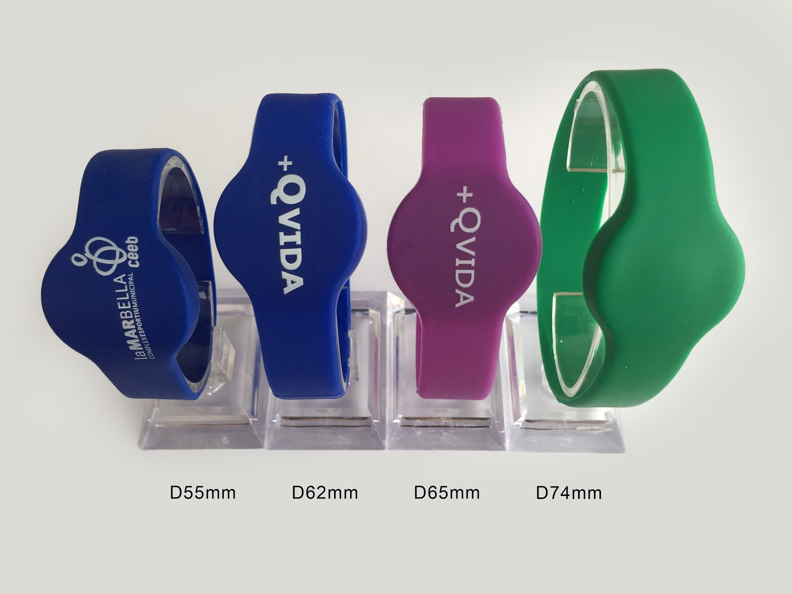
Vendor
Discount Wristbands
Dean Bryson
253 841 4057
discountwristbands@comcast.net
www.discountwristbands.com
Discount Wristbands is located in Tacoma and has supplied our bracelets for many years. They have excellent service and prices.

Cost
Order 1,300 RFID wristbands
Vendor quoted $1.47 per wristband plus shipping and any import tax required
$2.00 per wristband is my proposed budget to include tax, shipping, and imprinting
$2,600 budget for wristbands

Ken Lake Responsibilities
With the new system, our regular contractors will have some one-time upfront responsibilities, and some new ongoing responsibilities in the future. The board will need to decide how contracts will need to be adjusted and how people will be compensated for new one-time and ongoing responsibilities related to the RFID systems.

Currently, these responsibilities are probably assumed by the Corporate Secretary and Common Areas Manager.

Long term, it may make the most sense for our security contractor to manage the RFID system. If Ralph is unwilling or unable, we could create another security position that manages gate access, or wrap it in to a new contract when Ralph retires.

One-Time Implementation Responsibilities & Expenses
I suggest that the board pay someone a one-time fee for programming all the bracelets and setting up the software. For example, pay someone $1,300 to program software, bracelets, and locks, and distribute bracelets.
- Community owned laptop that houses RFID software and database ($1,200)
- Program software
- Program all 1,300 bracelets
- Issue all 1,300 bracelets (included in secretary contract?)
- Sync software to all 3 locks

Ongoing Future Responsibilities
Some of these responsibilities are included in current Secretary/CAM contracts, other responsibilities will be new. The board will need to decide who will take on the additional responsibilities and if additional compensation or a new position is appropriate.
- Maintain bracelet database: add new users, delete old users, change user restrictions
- Physically visit all 3 locks and sync bracelet database to locks each time a change is made to the database (plug laptop computer into locks to sync)
- Manage bracelet inventory (current secretary responsibility)
- Replace lock batteries annually (easy responsibility for CAM)

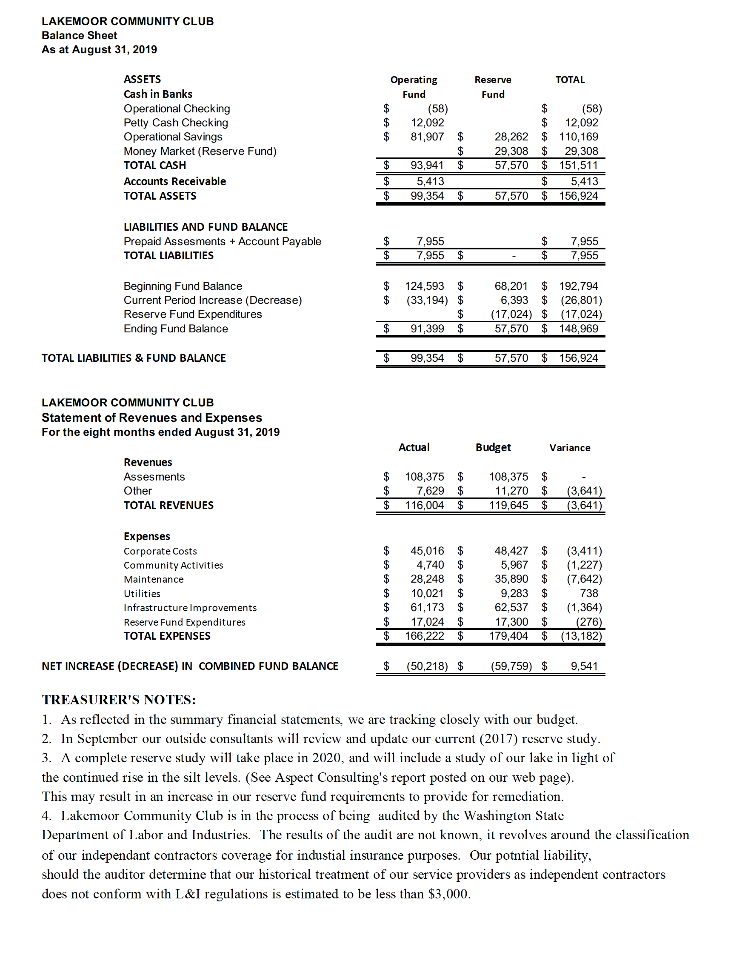
5. The board is in the process of reviewing the contracts with all of our service providers. We have completed the review of the Parks Manager, Ken Lake Security and our Corporate Secretary and renewed those contracts.
We will next be reviewing our management company contract and reserve study contract. We expect to send out RFP’s in the next few months. Once a comparative analysis of the proposals is complete we will invite the top 2 to 3 companies to make presentations to the board before reaching a decision.

